In the first two parts, we made coin sorter programs with no GUI implementation. Certain tweaks are added each part - In part 1, an API is called to additionally provide currency conversions [GBX, USD, MGA]. Part 2’s coin sorter behaves much less linear due to implementation of a main menu. Figure 1a and 1b shows the first UIs observed upon executing programs for part 1 and 2, respectively.

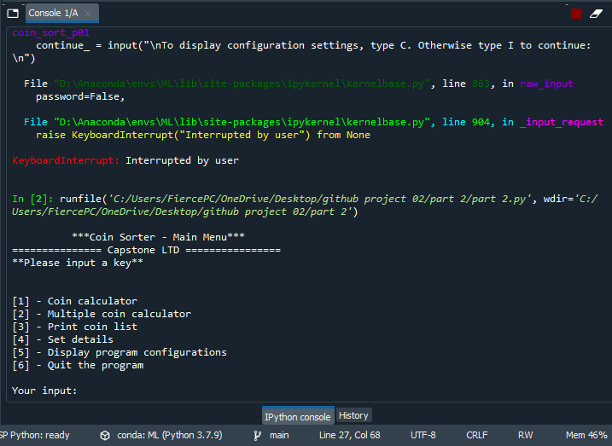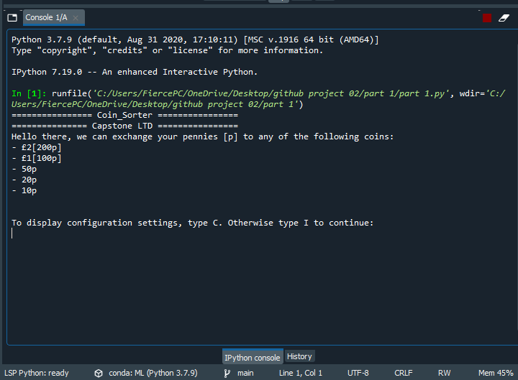

Part 01

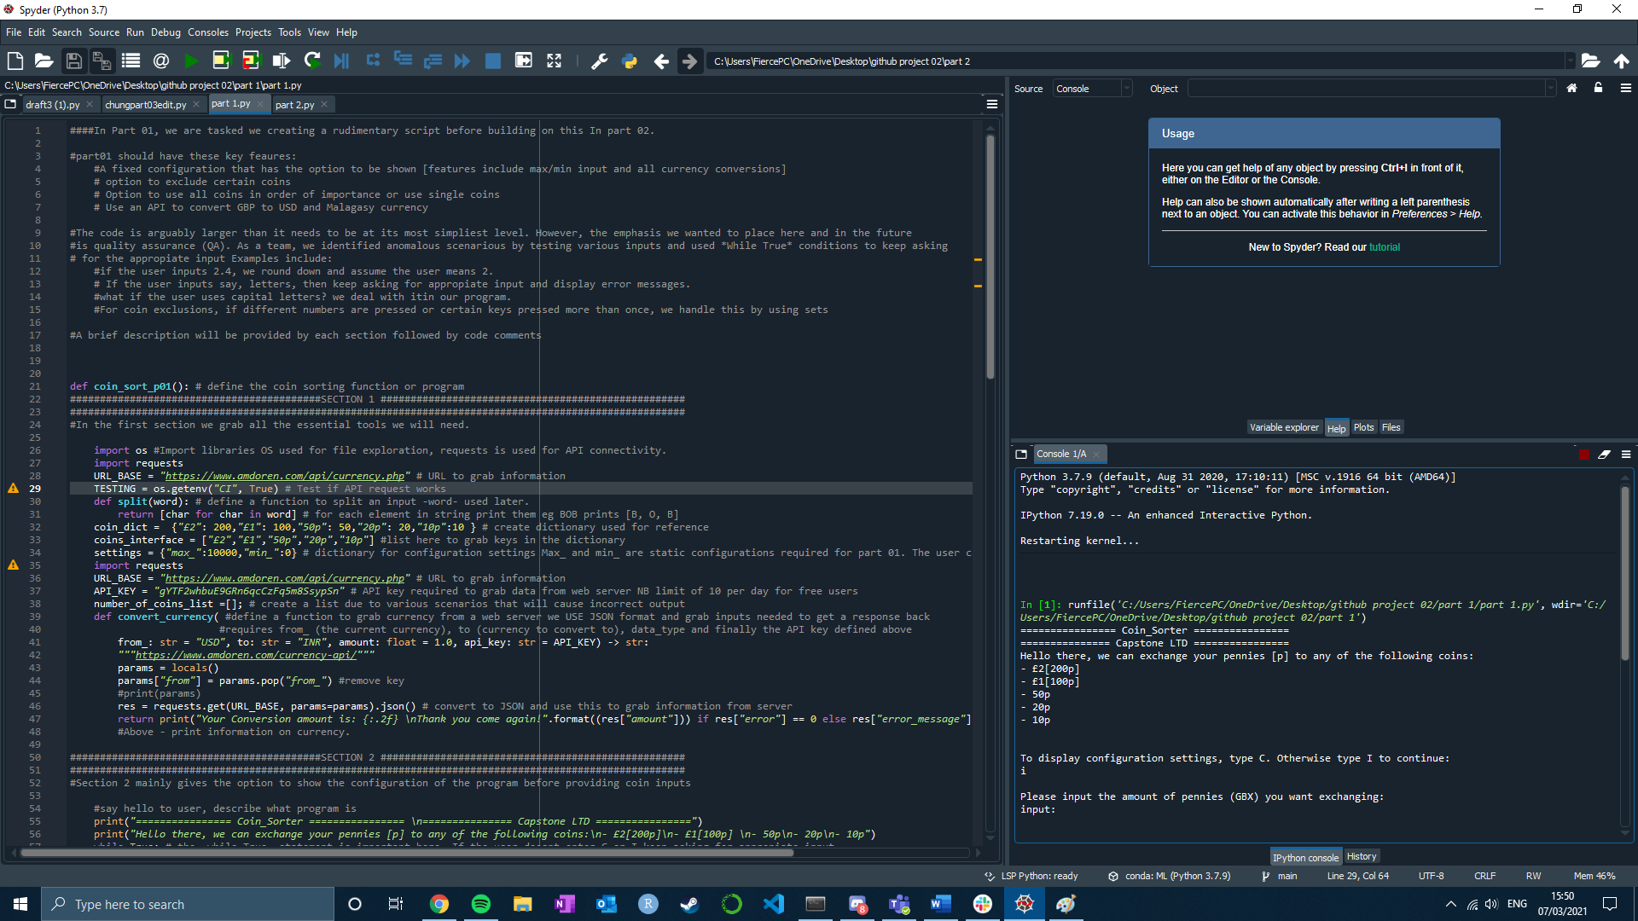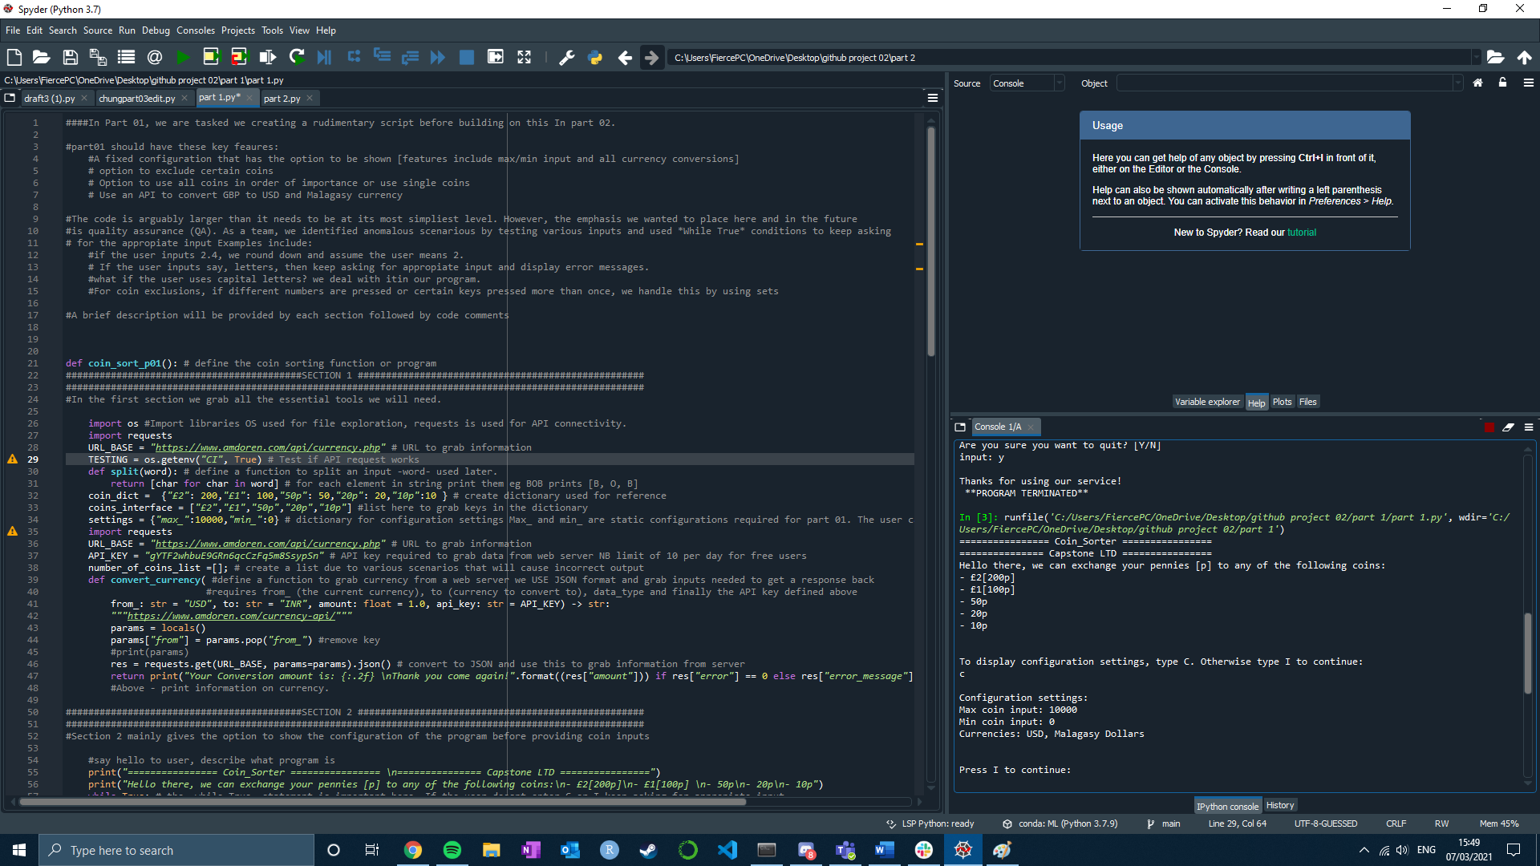The user can type -C- to show configurations, otherwise typing -I- will ask the user to provide a coin input:

The user can now input a certain number of coins and remove *certain types* of coins.

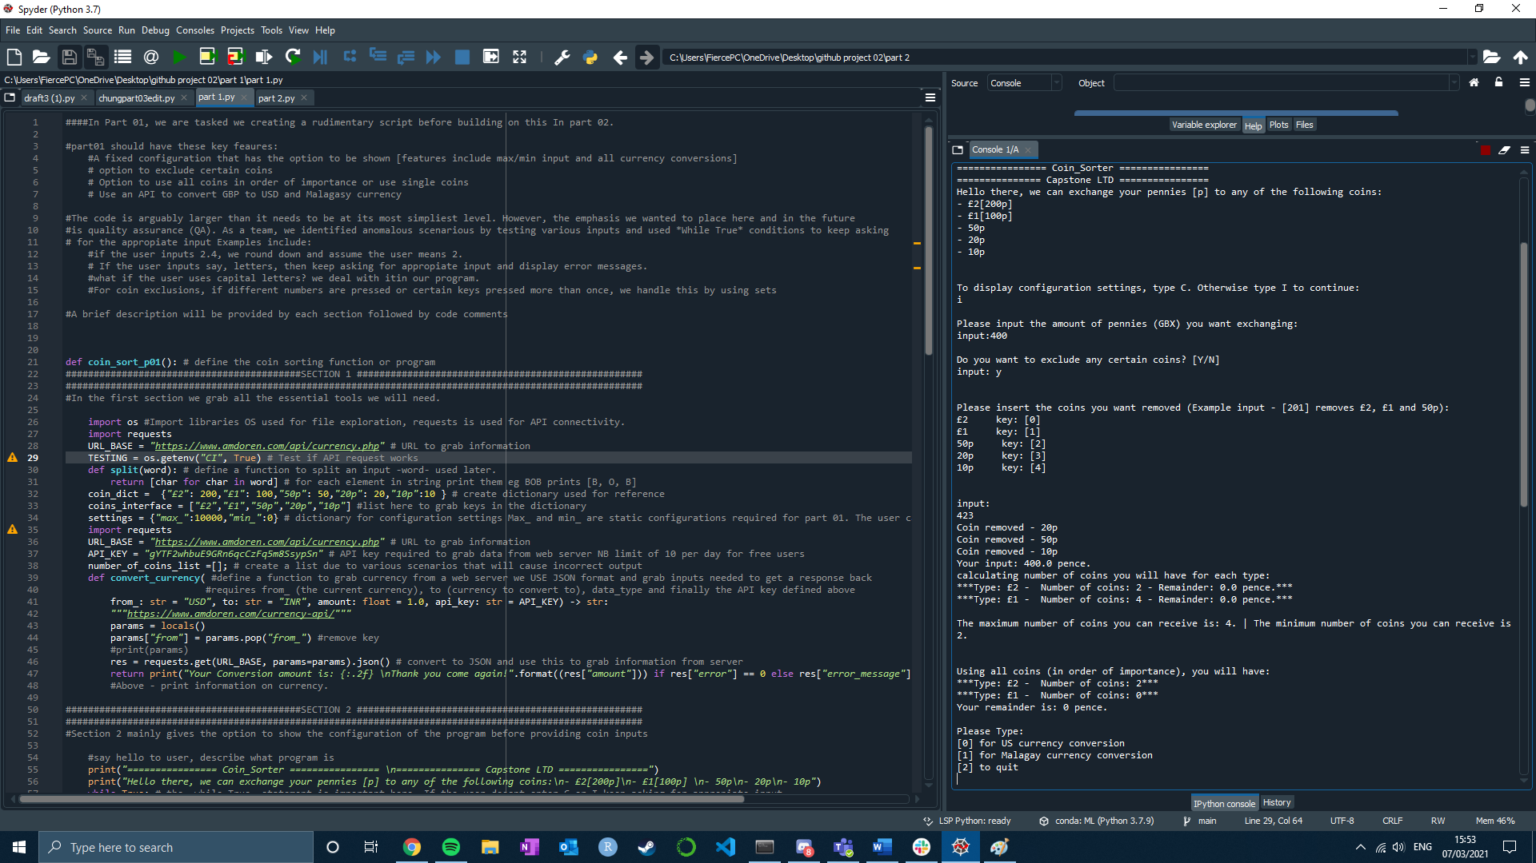In this example, I type 423 to remove 3 coins. The calculator outputs how many coins of each type I can receive followed by statement [max – coin/min -coin]

We additionally calculate in the order of importance, how much of each coins we can get.

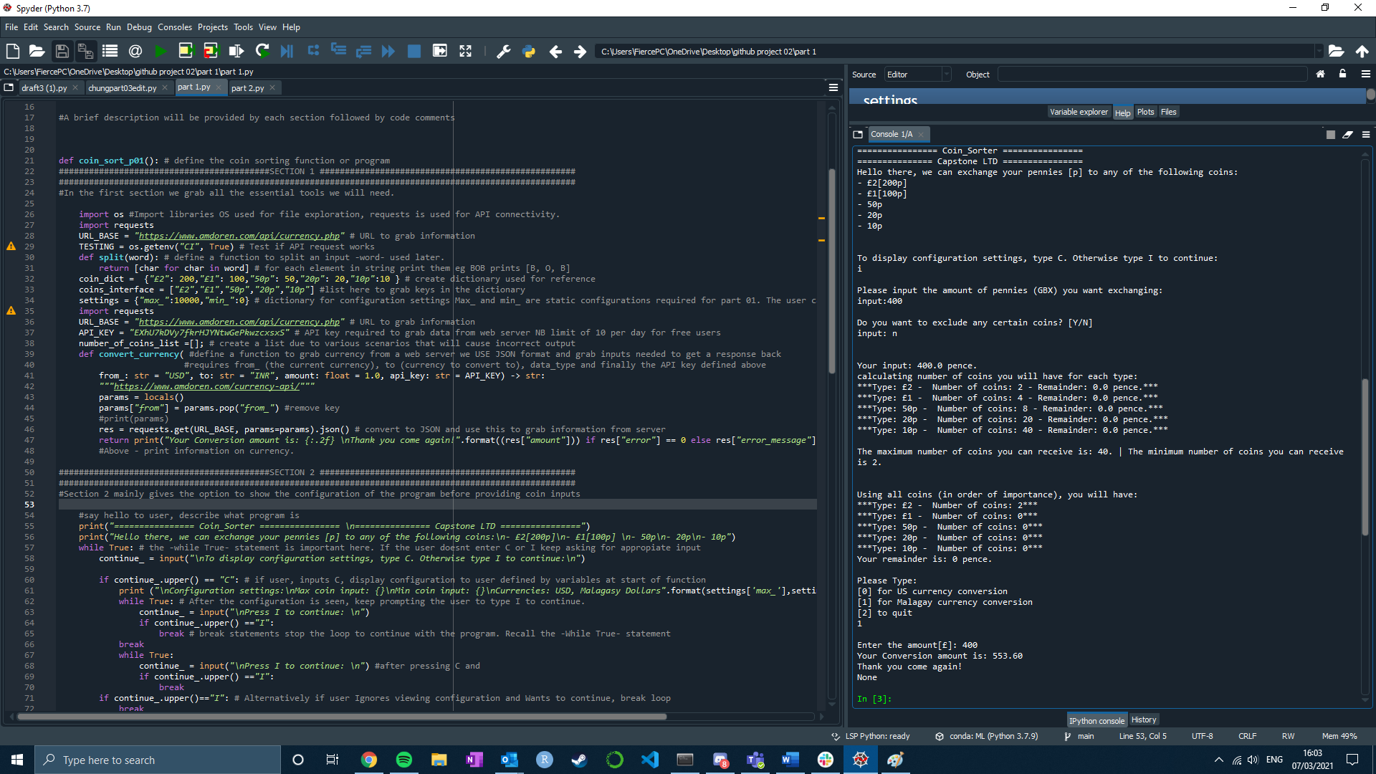

Finally, we prompt the user to type the key for additional options. The user is prompted the question [are you sure?] after asking to quit. For keys 0 and 1, the program calls to a database and extracts the most recent conversion.

In this example we convert 400 pounds to MGA. [NB – the library we used has a maximum request of 10 per API key]

Part 02

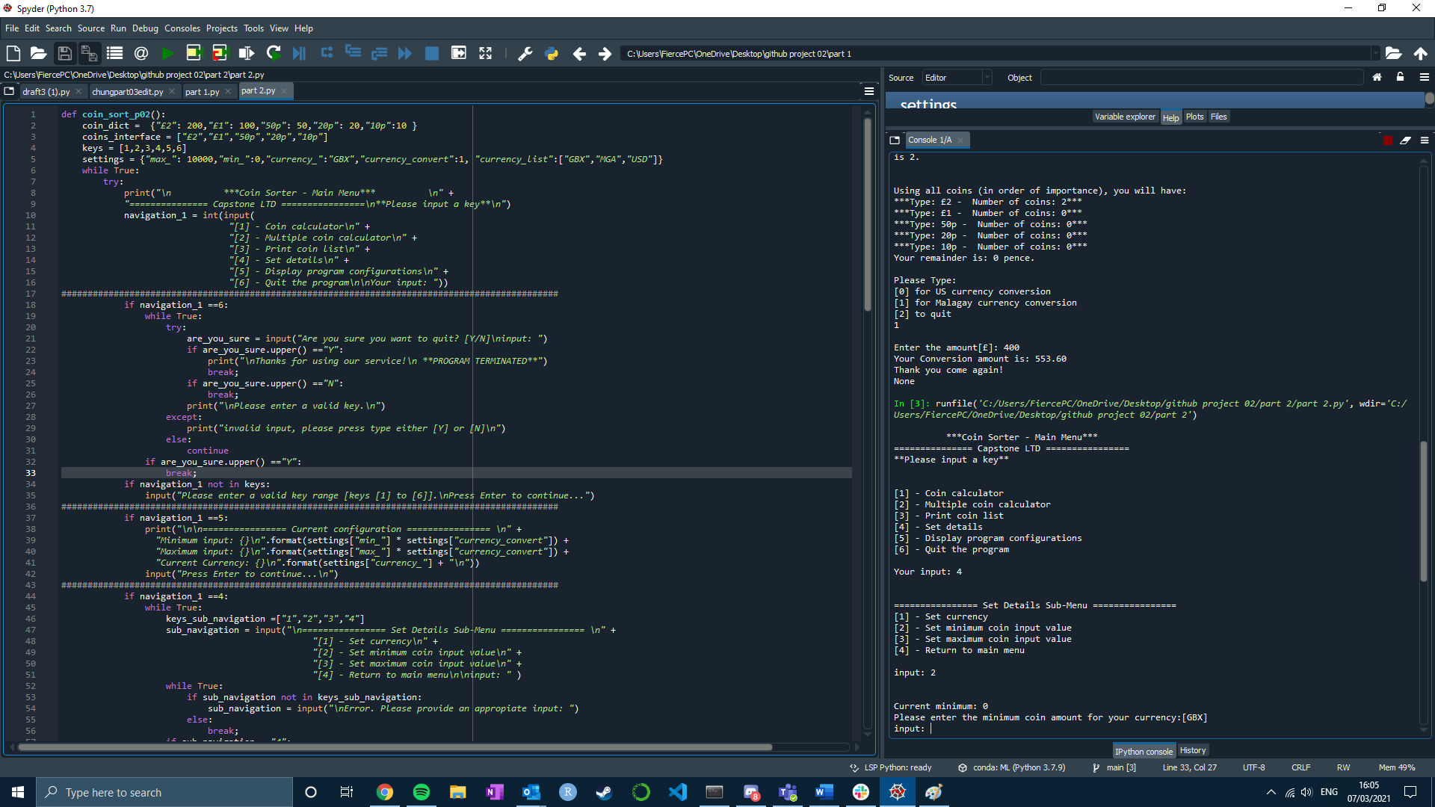

At the main menu keys [1] and [2] behave very similar to executions seen part 1. In this example, we type key [4] to show the user an additional menu asking to either change currency and set max/min.

After doing so, the user can be asked to go back to main menu.

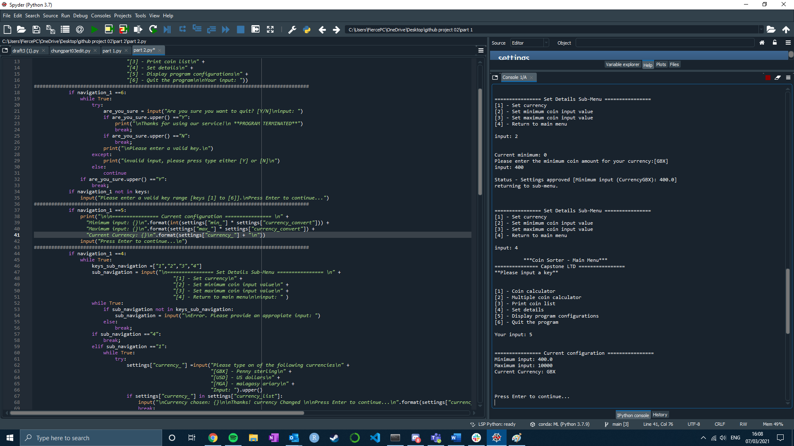

After pressing key [5]. The user is given configuration details [ error - the decimal point has since been removed]

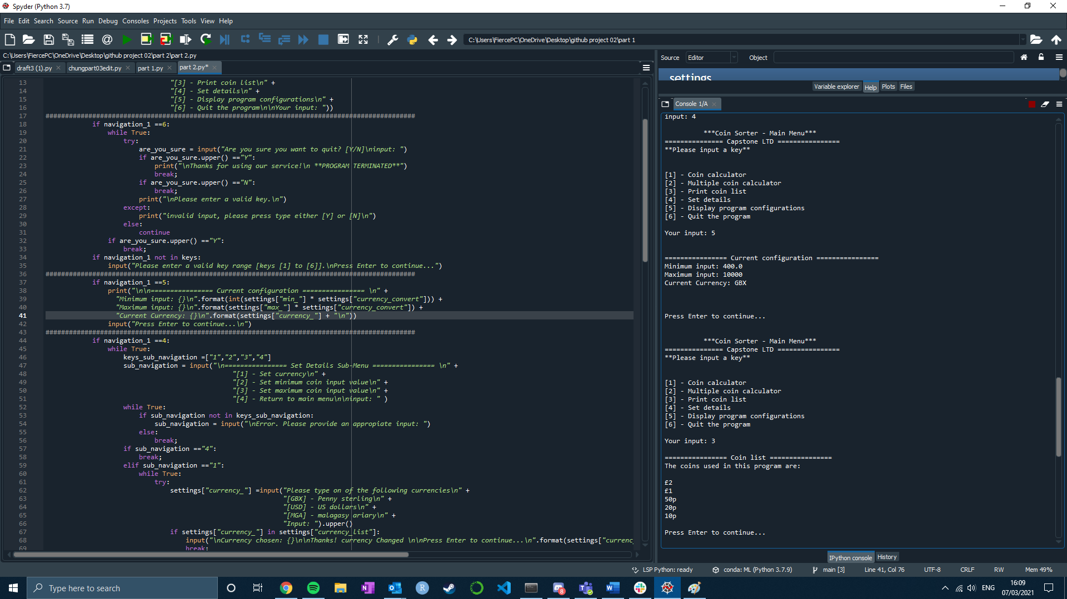

Alternatively, if key [3] is typed from the main menu, all the available coins are printed.